**Project Design Phase-II**

**Data Flow Diagram & User Stories**

|  |  |
| --- | --- |
| Date | 28 June 2025 |
| Team ID | LTVIP2025TMID49827 |
| Project Name | Heritage Treasures: An In-Depth Analysis of UNESCO World Heritage Sites in Tableau |
| Maximum Marks | 4 Marks |

**Data Flow Diagrams:**

The "Heritage Treasures" project aims to provide an in-depth analysis of UNESCO World Heritage Sites using Tableau. It involves a project planning phase covering product backlog, sprint planning, user stories, and story points. The project also includes tracking velocity and creating burndown charts to monitor progress. Data acquisition, cleaning, and visualization are key processes, leading to an interactive Tableau dashboard for users. The project follows an agile approach, utilizing sprints to manage development.

Example: DFD Level 0 (Official UNESCO)

**Example:** [**(Simplified)**](https://developer.ibm.com/patterns/visualize-unstructured-text/)

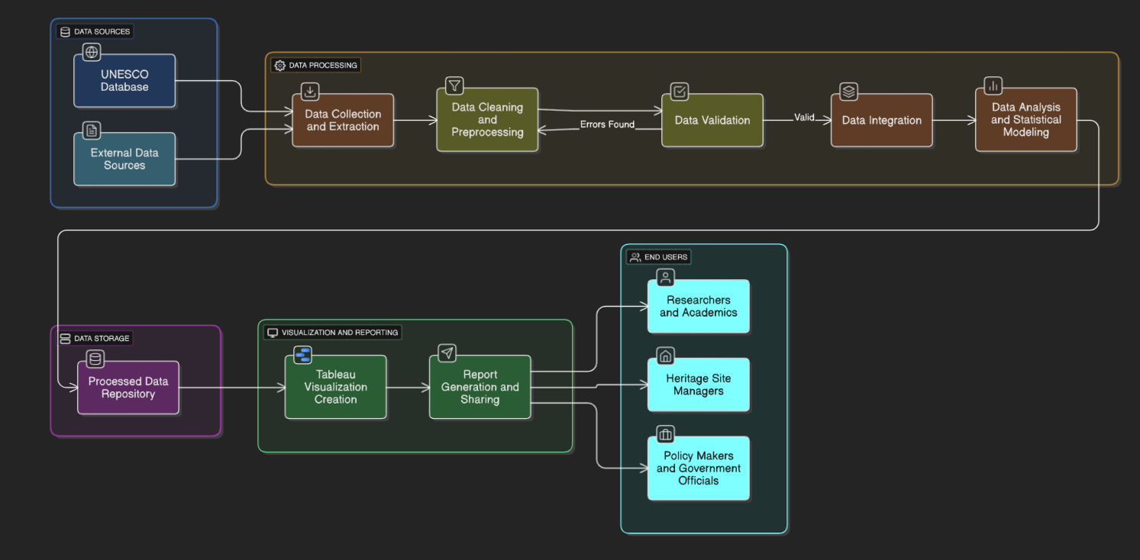

**User Stories**

Use the below template to list all the user stories for the product.

| **User Type** | **Functional Requirement (Epic)** | **User Story Number** | **User Story / Task** | **Acceptance criteria** | **Priority** | **Release** |
| --- | --- | --- | --- | --- | --- | --- |
| Customer (Mobile user) | Registration | USN-1 | As a user, I can register for the application by entering my email, password, and confirming my password. | I can access my account / dashboard | High | Sprint-1 |
|  |  | USN-2 | As a user, I will receive confirmation email once I have registered for the application | I can receive confirmation email & click confirm | High | Sprint-1 |
|  |  | USN-3 | As a user, I can register for the application through Facebook | I can register & access the dashboard with Facebook Login | Low | Sprint-2 |
|  |  | USN-4 | As a user, I can register for the application through Gmail |  | Medium | Sprint-1 |
|  | Login | USN-5 | As a user, I can log into the application by entering email & password |  | High | Sprint-1 |
|  | Dashboard |  |  |  |  |  |
| Customer (Web user) |  |  |  |  |  |  |
| Customer Care Executive |  |  |  |  |  |  |
| Administrator |  |  |  |  |  |  |
|  |  |  |  |  |  |  |
|  |  |  |  |  |  |  |
|  |  |  |  |  |  |  |